CCN404: Detailed Technical Specification
Version 0.6

Authors: Gavin McIntosh
Kevin Sprague

Date: 18-Jul-2007

0. Change Log

Version | Date | Author of Change | Section Changed | Description
0.1 | 04-Jul-2007 |  |  | Initial Draft
0.2 | 09-Jul-2007 | Gavin McIntosh | 0  1  4.1  4.2.3  4.3  4.4  4.5  6  Appendix A | Change Log added  Reference to embedded CCN404 removed  Further detail provided regarding changes to PSIS Query responses for inclusion of EncompassingEncounter  Removal of PSIS Queries  Text Section numbered and Artefact ID amended  Document Structure numbered  Renumbered and Discharge Example added  Decision 008 added  Diagram added to describe referencing of CRE types and coded entries.
0.3 | 12-Jul-2007 | Gavin McIntosh | 4.3  6  4.3.1 | Model updated to show nesting to 5 levels, thereby supporting H1-H6, as per W3C.  Decision 001 updated to provide more accurate description.  XML example amended to update referencing mechanism (coded entries and CRE types)
0.4 | 12-Jul-2007 | Gavin McIntosh | 0  Appendix A | Change Log amended  Diagram amended to correct error in coded entry reference value “a2” changed to “a3”.
0.5 | 16-Jul-2007 | Gavin McIntosh | 4.1  4.5.1  4.5.1 | Included brief statement of rationale for including EncompassingEncounter  Section numbering corrected  UUID error in example corrected
0.6 | 18-Jul-2007 | Gavin McIntosh | 6 | Decision 007 superseded by Decision 010 which states a more relaxed requirement with regard to coding and indexing of medications and allergies.
0.7 | 24-Jul-2007 | Gavin McIntosh | Appendix A | Changed reference to decision 007 to decision 010.

1. Introduction

NHS CFH has approved CCN404 for formal impact assessment by BT. This document provides an authoritative statement of the current understanding of the detailed changes planned for the CDA message structure which will be brought about by CCN404. The purpose of the document is to assist BT in providing an accurate impact assessment and to communicate progress on CCN404 to key stakeholders. The document does not have any contractual significance and must not be relied upon for development purposes

2. Audience

This document will be of interest to internal and external technical and business stakeholders, for example:

- CFH Clinical Domain message developers
- CFH Clinical Advisers
- CFH Clinical Domain Business Analysts
- CFH Clinical Domain Project Managers
- Local Service Providers
- National Service Providers

3. Distribution

This document will be updated on a regular basis and published on the PSIS 2008-A SharePoint site. It will also be sent directly to representatives of the key stakeholder groups identified in Section 2.

4. Detailed Statement of Changes to CDA Documents

4.1 Encompassing Encounter

Encompassing encounter will be added to the following documents

- Discharge
- Outpatients
- Emergency Department

This will be a new template COCD_TP146060UK01 which uses the existing template COCD_TP145022UK01 and COCD_TP145024UK01. Template COCD_TP146060UK01 has been agreed with NHS CFH business teams and clinical advisers as fit for purpose.

PSIS Query responses will be updated as follows:

- Addition of EncompassingEncounter.effectivetime
- Addition of HealthcareFacility.code

The reason for including EncompassingEncounter is to provide receiving systems with metadata that provides further clinical context regarding the documents held on PSIS. Making this data available will help clinicians to target their queries.

Encompassing Encounter Template

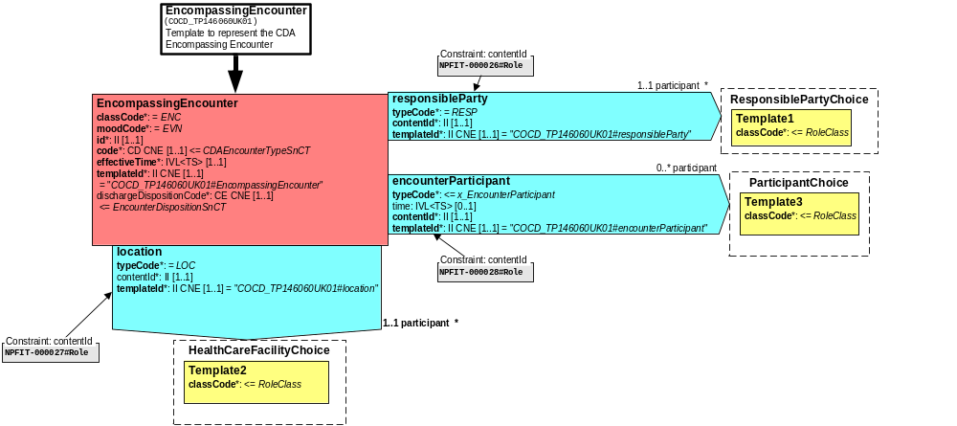
Fig. 1

Location Participant constraint: content ID Responsible Party Participant constraint: content ID
NPFIT-000027#Role NPFIT-000026#Role

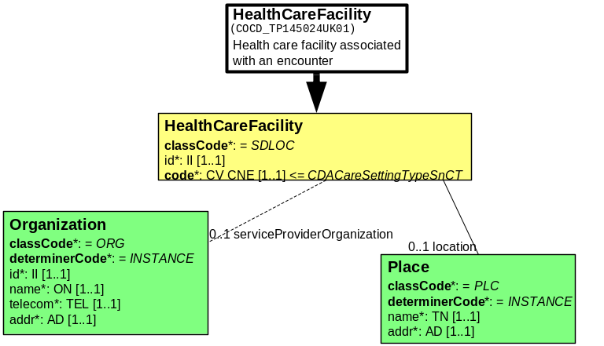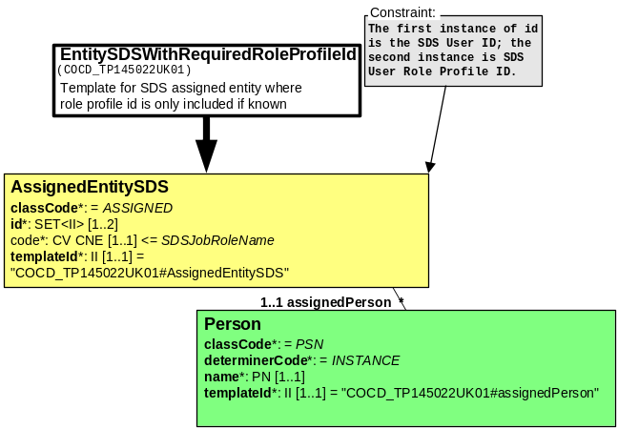
Fig. 2 Fig 3

Encounter Participant constraint: content ID
NPFIT-000028#Role

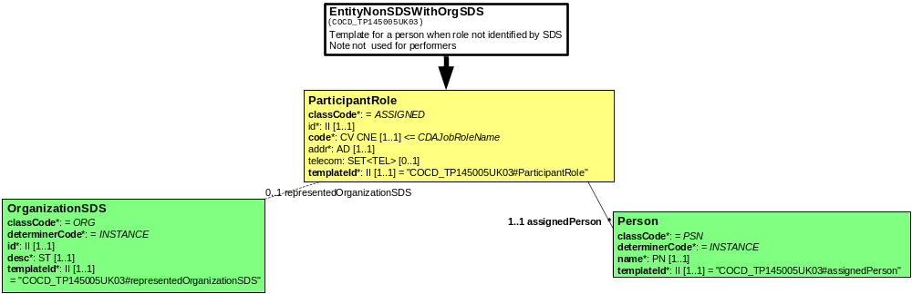
Fig. 4

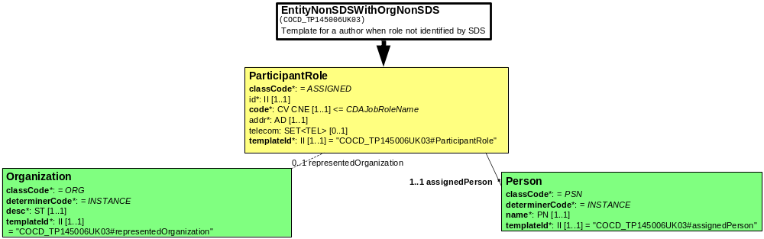
Fig. 5 Fig. 6

EncompassingEncounter will be represented in the domain models as follows:

Encompassing Encounter

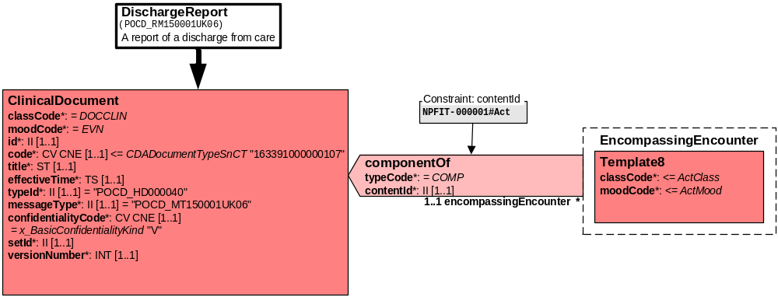
Fig. 7

4.2 Changes to CDA document structure

4.2.1 The following Documents will have business section templates and CRE type section templates removed:
- Discharge
- Outpatients
- Emergency Department
- HealthSpace

4.2.2 The following Documents will have CRE type sections removed from their templates (these do not contain Business Sections):
- Nullification
- Refusal to seal
- Unseal Report
- Seal Report

4.2.3 The following Documents will have their text section templates remodelled as shown in Fig 8 below
- Discharge
- Outpatients
- Emergency Department
- HealthSpace
- Nullification
- Refusal to seal
- Unseal Report
- Seal Report

4.3 TextSection

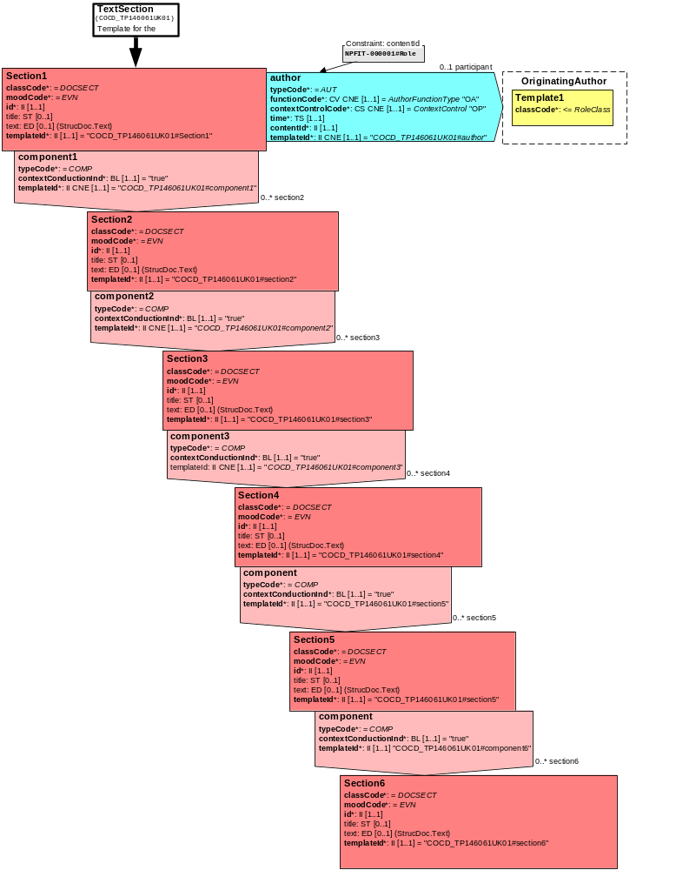 Fig. 8

The new structure for clinical CDA documents will now be as shown in Figure 9 below.

4.4 Document Structure
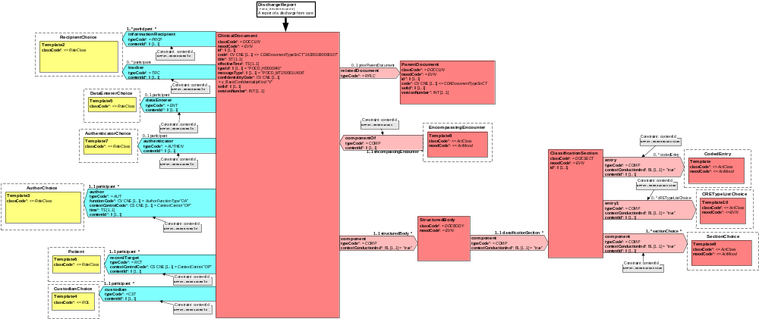
Fig. 9

4.5 Examples
Examples will be included as they are completed. The XSL output uses the default CDA Stylesheet and is provided for indicative purposes only.

4.5.1 Discharge 1 (xml) Discharge 1 (XSL Output)
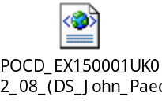

5. Assumptions

ID | Description | Level of Confidence
001 | There will be no use of the old-style CDA documents (i.e. pre CCN404), so there is no requirement for the CCN404 impact assessment to make provision for backwards compatibility with documents of that structure. | High

6. Decisions

ID | Description | Date
001 | Number of text sections to be used.  Multiple text sections will be used. Specifically, there will be a relationship of 1..* text sections, which may be nested to a depth of no more than 5 sections. | Updated  11-Jul-2007  04-Jul-2007
002 | Number of authors of text section(s)  There should be only 1 author for each Level 1 text section and it should be added to a text section only if it differs from the document author. So, there will not be authors for sections lower than level 1, except in the case of coded entries, where the author is automatically included. | 04-Jul-2007
003 | Templates and Original Text  Some templates do not allow original text and therefore need a new flavour of datatype. (see action 001 below) | 04-Jul-2007
004 | CDA referencing mechanism using #  New flavour of CFH URL datatype to be created to support CDA referencing mechanism using #. (see action 002 below) | 04-Jul-2007
005 | Text Section Title  Text Section Titles are optional and used for rendering purposes only, i.e. to provide a mechanism for achieving the equivalent of soft headings, along the lines of H1, H2, H3, etc. PSIS is not expected to do anything with Text Section Titles. | 04-Jul-2007
006 | Supplier Formatting Guidance  Guidance on the formatting of text sections will be provided to Suppliers via the Implementation Guidance for Suppliers (ref: NPFIT-FNT-TO-DPM-0626). This will be guidance in the true sense and will not constitute a requirement. | 04-Jul-2007
007 | Coding and Indexing  For Medications and Allergies it is mandatory to use coded entries and to index against CRE types. For all items other than Medications and Allergies, CRE types must not be used, except and until CFH provides explicit guidance on their use. The Implementation Guidance for Suppliers will be updated to reflect this change. The enforcement of indexing for Medications and Allergies will be achieved using a schematron. | 04-Jul-2007
008 | Clinically Relevant Time  It has been agreed that the clinically relevant time template is no longer required. | 09-Jul-2007
009 | Referencing Coded Entries and CRE Types  Since only coded entries will be indexed by CRE Type, it has been decided to reference from CRE types to the UUID for the relevant coded entry, rather than from the CRE Type to the relevant text section. | 12-Jul-2007
010 | Coding and Indexing  For Medications and Allergies, coded entries are required but not mandatory and likewise for indexing against the relevant CRE types for meds and allergies. For all items other than Medications and Allergies, CRE types must not be used, except and until CFH provides explicit guidance on their use. The Implementation Guidance for Suppliers will be updated to reflect this change. This supersedes decision 007 above. | 18-Jul-2007

7. Actions

ID | Description | Date | Owner | Progress | Status
001 | Refresh templates to include datatype flavours that support original text. | 04-Jul-2007 | Kevin Sprague  Ravi Natarajan
002 | Create new flavour of CFH URL datatype to support CDA referencing mechanism using #. | 04-Jul-2007 | Ravi Natarajan

Appendix A: Referencing Coded Sections
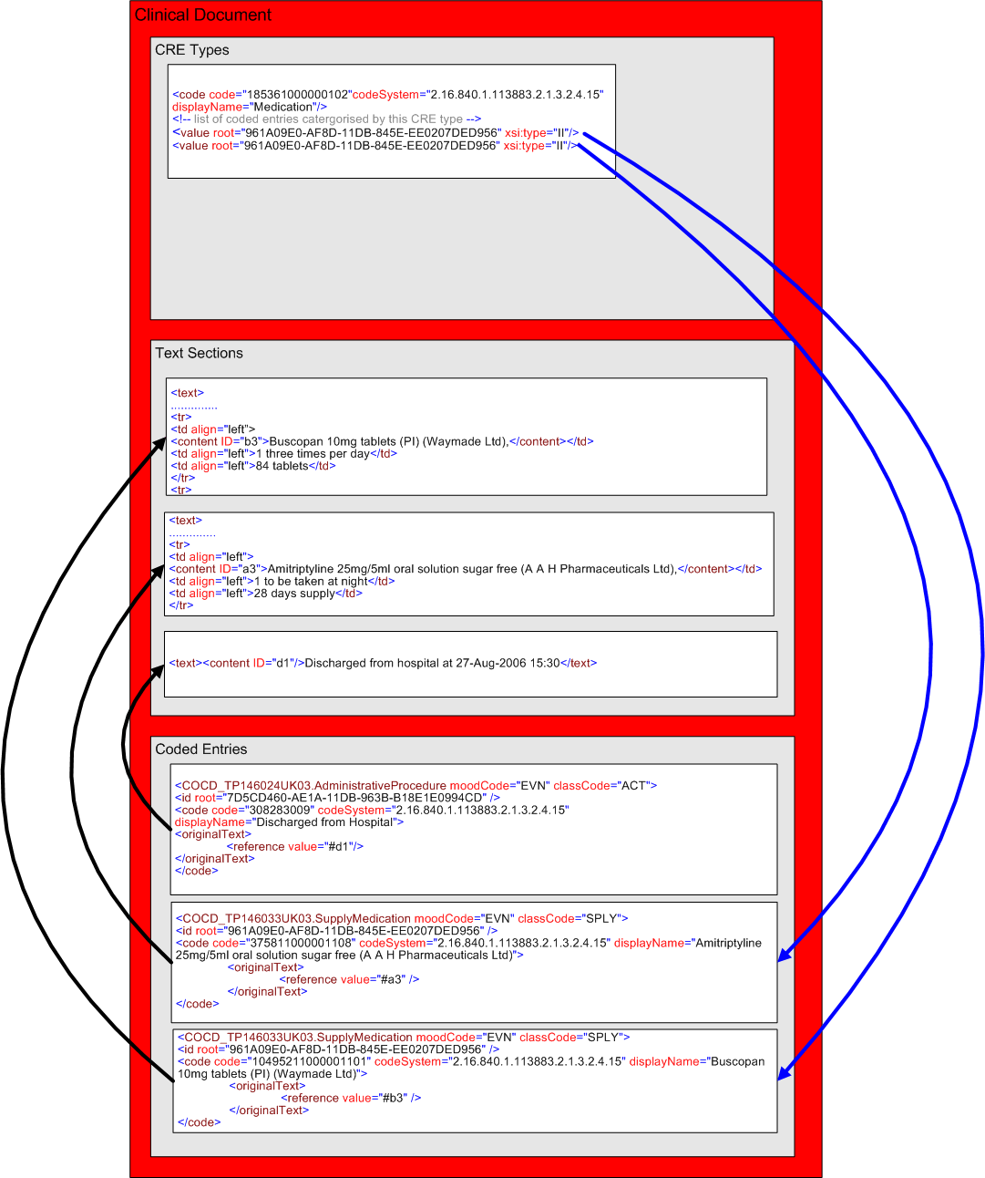
Fig. 10
Fig. 10 represents the way in which coded entries and CRE types will reference text. NB: in line with decision 010 above, CRE types must only be used for clinical data that it is mandatory to code; however, it is perfectly acceptable to code items even if such coding is not mandated (as exemplified in Fig. 10 where the administrative procedure is coded but not indexed against the CRE type Administrative Procedures

